**SECTION A – WEBSITE PLANNING AND DOCUMENTATION**

REQUIREMENTS AND SPECIFICATIONS

Goals

The requirements and specifications of a website differ depending on the purpose and target audience of the website, the website we are looking at today is the Warner Bros it is a film and entertainment movie website as explained by the Warner Bros free encyclopedia. The Wikipedia explains that the purpose of this website is to allow the buying and selling of movies over the internet, the Warner Bros website has different entertainments from movies to tv shows to even games, it even has its own clothing line where you can buy their products. The website informs you on what movies and shows are soon to come and what movies are available, all one has to do is click on the website to get all this information. The goal is to build a relationship with its customers, this way we have regular fans that sign in to watch shows on the website.

Audience

The Wikipedia further explains the type of audience for this website ranges from children to even older adults, the Warner Bros website does not limit its audience but instead caters for a range of ages. We can have children from the ages 6 and above to watch movies like the emoji movie, we can have grown adults who love action and thriller movies, we also have shows for teens who love romcoms and anime. The website has all sorts of different movies and series for different ages. Also we make the website easy to understand for all these ages, there is no complex technologies used or you don’t need to be a technological expert to use the website.

INFORMATION DESIGN AND TAXONOMY

Sitemap

The sitemap below is a visual representation of the content and pages in the websites, it outlines the websites structure and helps visitors navigate and understand the content of the website, similar to a blueprint. As shown below we have the main page and subpages linked together

PAGE TEMPLATE DESIGN

Wireframe

Below we have the wireframe of al the subpages, the wireframe shows the structure of the website as you can see below, gives outsiders an idea of how your website looks.

HOME

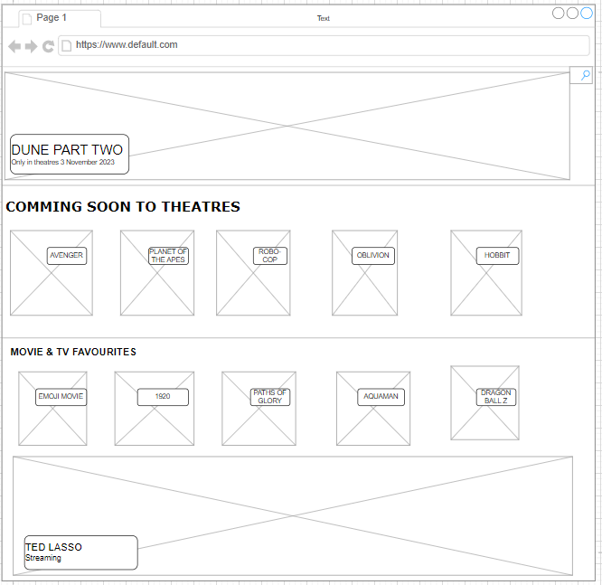

TECHNOLOGIES USED

We have different software tools and graphic tools used in developing websites, for coding this specific websites I used Visual Studio Code, it is code editor used for building an debugging modern web and cloud applications. I also used draw i0 for the designing and development of the sitemap and wireframes, lastly I used the snipping tool app to take screen shots of my evidence.

QUALITY ASSURANCE

Below are the different browsers that where used to test the website, we used Microsoft Chrome and Microsoft Edge, and as you can see the website works the same. The lay out is the same and nothing was disrupted, showing that the website is compatible to different websites.

